Division(s): N/A

ITEM PF8E

PENSION FUND COMMITTEE- 25 FEBRUARY 2005

OVERVIEW AND OUTLOOK FOR THE INVESTMENT MARKETS

Report by the Independent Financial Adviser

- As one tries to look ahead at the prospects for financial markets for the rest of the year there seems to be more major factors that could have a significant impact than usual. In addition to the normal factors surrounding the rate of economic growth and the prospects for corporate profits, there are the trends of house prices and its impact on consumer spending, oil prices, the trend in the US dollar coupled with the massive US balance of payment deficit and will China achieve a soft landing from its too fast rate of growth, plus the ever present wild card of terrorism.

- Economic growth is forecast to slow after the sharp recovery from the near recession in 2002-3, but the current softening in growth in late 2004 is not expected to continue.

 | Actual | Consensus | Forecast
 | 2004 | 2005 | 2006
UK | 3.2% | 2.5% | 2.5%
Euro zone | 1.8% | 1.8% | 1.7%
USA | 4.4% | 3.5% | 2.5%
Japan | 2.9% | 1.5% | 1.8%

This calm picture could be upset by a number of factors.

  - House Prices

House prices have more than doubled since 1997 and are now hugely over valued, being well above the previous peak in 1990, as the chart below shows.

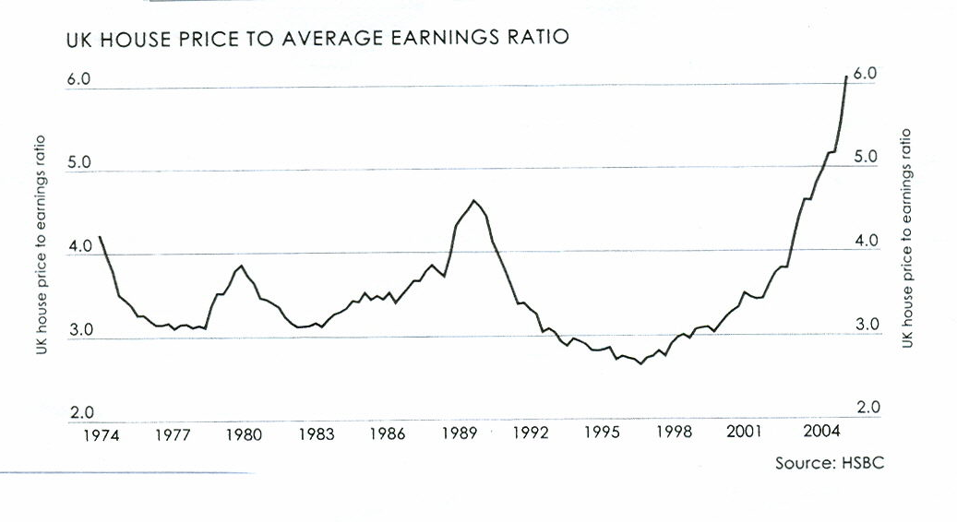

Rarely does a market, having risen so sharply, settle into a gentle rise or a steady plateau. The probability is prices will decline modestly for a few years amounting in total to say 10-20%, while wages and salaries rise so bringing the ratio down to a more moderate level. The Bank of England has said the link between house prices and consumer expenditure has been broken in recent years but this was in the last stages of the rise. A decline in prices even from a ‘bubble peak’ still makes people feel less well off and so they will spend less. This would allow room for more corporate investment and exports. A sharp break in house prices could, of course, put the economy into recession. The US and several European countries also have the problem of over-valued house prices.

  - Oil prices

Oil prices rose from a recent low of US $25 a barrel in May 2003 to a peak of nearly US $50 a barrel in October 2004, but then backed down to US $40 at end December before recovering to around US $45 as the chart below shows.

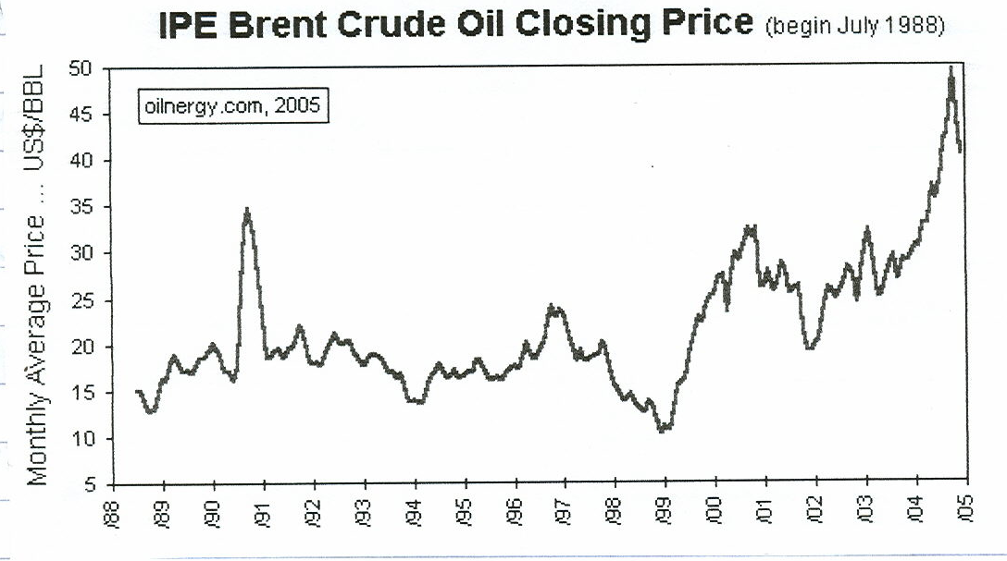

Factors which drove prices to a peak such as supply constraints in Nigeria, Russia, Venezuela etc are beginning to ease (Russia may be only temporarily) while demand should moderate with modestly lower global economic growth, particularly in China. Although the peak in prices has probably been seen, the natural price of oil may have risen to around US $35. A price of US $45 upwards if maintained would have serious consequences for the UK and global growth.

  - The US Dollar

The US Dollar has been falling against other currencies since mid 2002, and was down 29% at the end 2004 before making a very modest recovery. With the ever widening US current account deficit (see chart below) the US Dollar probably has further to fall. Provided the decline continues to be gradual, it should have little impact on global growth, but a sudden downward break would cause turmoil in the foreign exchange markets, reduce economic growth in Asia, could push the EU into recession and the UK would feel the impact of all this. At some point the US deficit has to be brought under control.

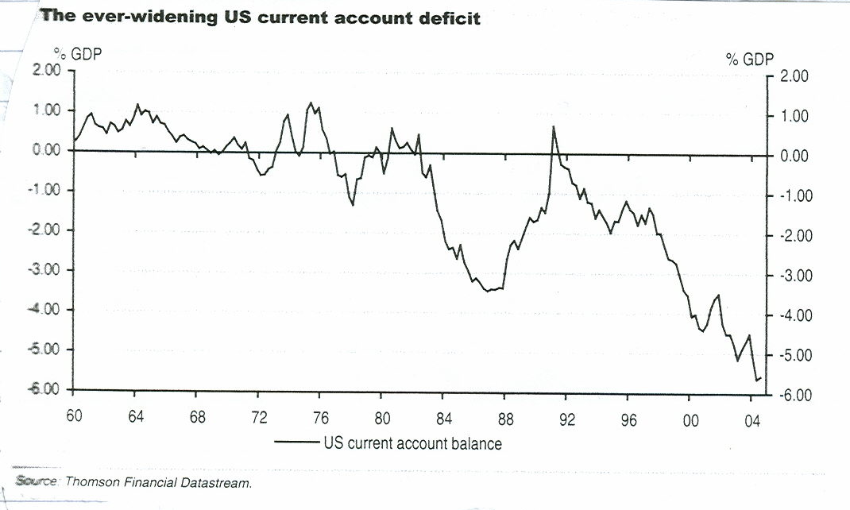

  - China

China is a significant and increasing part of the global economy. It looks as though the Chinese authorities are successfully restraining the too rapid growth of the economy from over 9% to nearer 7%, but if they should fail and the economy have a hard landing, it would not just impact Asia, but also the rest of the world.

Markets

- Provided the factors listed above keep within bounds and there is no major act of terrorism, most equity markets will probably continue to climb the ‘wall of worry’, modestly. In the UK the FTSE 100, which until September last year had traded between 4300 and 4600, broke out upwards and is now well over 4900. It could hit technical resistance at over 5000 and labour for sometime at that level. Similarly, the FTSE All Share index at 2500 could find resistance a little higher. However, rising profits have brought the price earnings ratio valuation down to a down to a more reasonable level of 13. In the EU, although economic growth is low, the strong Euro is making companies in some countries, particularly Germany, force down unit labour costs and so profits are rising appreciably. This should support further progress in equity markets. After twelve wasted years corporate Japan is restructuring and rising profits are bringing the price earnings ratio down to around 17, the lowest for 30 years. The markets could be in the middle of major bull trend. After the pause in the final quarter of 2004, other Asian markets are making modest progress. The outlook in the US equity market is more clouded. The profit cycle is now at an almost 40 year peak of 8% of national income and will probably ease back from that level. The share of wages is now beginning to edge upwards. The market is already overvalued on a prospective price earnings ratio 17. It could well correct from mid year on and spend a number of years trapped in a trading range, as it did in 1968-1982, while a modest rise in profits brings the price earnings ratio down to a more reasonable level.

- Interest rates in the UK have probably peaked with the Bank of England’s ‘repo’ rate having been lifted from 3 ½ % to the currently 4 ¾ % where it will probably be held until it starts to move down later this year. The European Central Bank has held its rate at 2% since mid 2003 and it will probably continue to do so, unless further strengthening of the Euro forces it to cut it. Similarly, Japan will continue to hold rates at zero. In contrast, the US Fed. which has already lifted its funds rate from 1% in June 2004 to the current 2.50%, will probably continue lifting it in ¼% steps to 3 ½ % to 4% range.

- Against this background bond prices will probably under perform equities. Prices in the EU, where the government benchmark yields around 3.5%, could rise (ie yields falls) particularly if the Euro hardens further. In the UK prices could be under downward pressure with the need to finance the huge budget deficit, so yields on the 10 year benchmark could move up from the present 4.5%, while in the US the combination of higher short term Fed. Funds rate, a huge budget deficit and a weakening currency will probably push yields higher (prices down) from the present 4.0%.

- Clients of the UK and US stock markets and currencies are attached.

A.F BUSHELL
Independent Financial Adviser

February 2005


